ORAL or POSTER
Investigation of Elastic with carbon fiber-reinforced plastic (CFRP) material

ABSTRACT
In this study, the stresses occurring in the disk consisting of carbon fiber reinforced plastic material (CFRP) were investigated. Concepts such as temperature and modulus of elasticity are very important for the correct application of thermal stress analyses. In this study, the temperature distributions of 30°C, 60°C, 90 °C, 120 °C, 150°C, which are the most ideal for machine parts, were considered. CFRP materials are currently preferred in unmanned aerial vehicles, UAVs, SIHAS, aircraft industry. They are fiber-reinforced polymer materials obtained by combining carbon fibers with a polymer matrix, showing high strength, high hardness, and strength. The stress values obtained at the end of the study were compared among themselves and shared with the literature in graphs. It is thought that the mathematical change in the temperature values affecting the disk with CFRP material also directly affects the thermal stresses. At the same time, the results obtained were analyzed with the ANYS 2023 finite element program. It has been seen that the results obtained are compatible with each other.

Keywords: CFRP disk, Elastic tensile, Elastic modulus
Copyright © 2024 by author(s), DergiPark and JOEBS. This work is licensed under the Creative Commons Attribution International License (CC BY 4.0).
CC BY 4.0 Deed | Attribution 4.0 International | Creative Commons
Received :**.**.20**.
Accepted :**.**.20**.

How to cite this article:

- INTRODUCTION
Disks are generally mandatory parts to be used in machines and machine parts. Disks are generally used in aircraft industry, space industry, vehicle braking systems. The correct determinationera of the disk material is directly proportional to the temperature sensitivity of the machine.When the literature review was conducted on this subject, it was seen that the stresses on disks with different materials were examined. However, there have not been any studies on stresses occurring in disks made of carbon fiber-reinforced plastic (CFRP) material. Looking at the research conducted on thermal stresses; The changes in the brake disk with cast iron material used in vehicles have been studied. As a result, it was determined that in addition to the gray iron material, the coefficient of friction with graphite flakes increased, and in addition, the effect also increased if steel-containing primers were used (1). The results obtained have been shared in graphs (2). In another study; Fractional order theory has been applied in a hollow modeled cylinder with thermoelastic material (3). In another study; Overview of residual stresses and their measurement and X-ray residue analysis was investigated at the surface region of the material with a single crystal (4, 5). In different studies, stresses occurring in cylindrical materials were examined again (6, 7). In a different study, the stresses of nonlinear and rotating disks were investigated. When the results obtained from the FGM disk were examined, it was found that the biggest diskrepancies were in the radial displacement part (8). Disks, on the other hand, can be used in the functional areas of machine parts. The lightness, high strength, good corrosion resistance and high-quality thermal insulation properties of the CFRP material disks used in this study in-crease the importance of this study. With this study, the elastic tensile behavior of the disk with CFRP material in the maximum and minimum operating range was determined by using the lowest temperature of 30 0C and the highest temperature of 150 0C. The findings obtained were compared with other studies in the literature-type. It was concluded that the results obtained gave the correct result.
- MATERIALS AND METHODS
The temperatures determined in this study are 30 °C, 60 °C, 90°C and 120°C respectively. The plane stress is σ_{Z} = 0 (9). The modeled disk is given below.
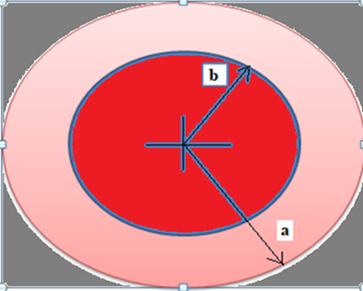
Figure 1. Carbon fibre-reinforced plastic (CFRP) disk
For the determination of radial and tangential stresses, the general equation given below can be taken as a reference (9)
$$a_{θθ}r^{2} \frac{d^{2}F}{{dr}^{2}}+a_{θθ}r\frac{dF}{dr}-a_{rr}F=-α_{θ}r^{2}\frac{dT}{dr}+α_{r}Tr-α_{θ}Tr (1)$$
In equation 1 above, the effect of temperature in different regions is given by the formula.
$$T\text{=}\frac{T_{0}}{b^{2}-a^{2}}\left(a^{2}-r^{2}\right) (2)$$
$${\text{σ}}_{\text{r}}\text{=}\frac{\text{F}}{\text{r}}\text{= }C_{1}r^{k-1}+ C_{2}r^{-k-1}+{Ar}^{2}+C (3)$$
$$σ_{θi}\text{=}\frac{dF}{dr}=kC_{1}r^{k-1}+ {kC}_{2}r^{-k-1}+{3Ar}^{2}+C (4)$$
$$A\text{=-λ}\frac{{3(α}_{θ}-α_{r})}{a_{θθ}(9-k^{2})} (5)$$
$$C\text{=λ}\frac{{(α}_{r}-α_{θ})b^{2}}{a_{θθ}(1-k^{2})} ( 6)$$
$$\text{λ=}\frac{T_{0}}{{(b}^{2}-a^{2)}} (7)$$
$$k^{2}=\frac{a_{rr}}{a_{θθ}} (8)$$
$$C_{1}\text{=}\frac{Aa^{k+3}+Ca^{k+1}-Ab^{k+3}-Cb^{k+1} }{{(b}^{2k}-a^{2k)}} (9)$$
$$C_{2}\text{=-}C_{1}a^{2k}-Aa^{k+3}-Ca^{k+1} (10)$$
The engineering coefficients A and C "λ" and k are given below.The disk modeled in the ANSYS 2023 program is given in Figure 2 below.
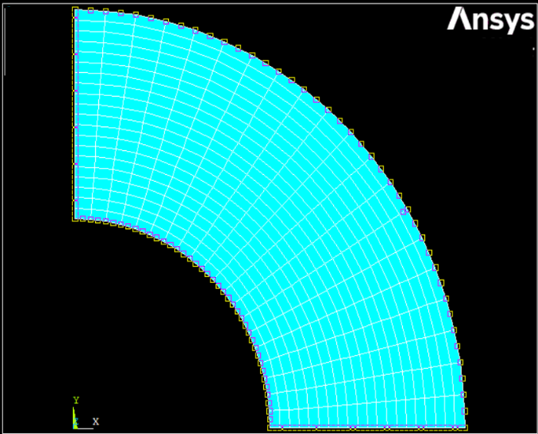
Figure 2. Disk modeled at ANSYS 2023

The results obtained through the ANSYS 2023 program are given in Figure 3 below.
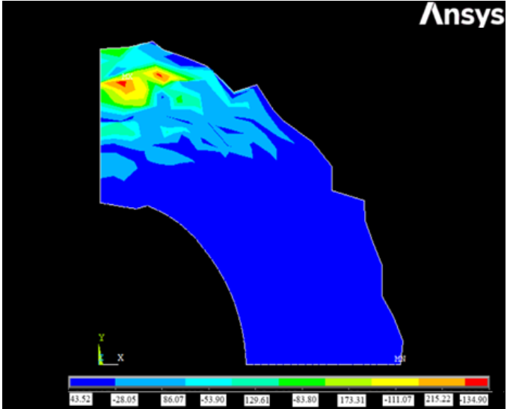
Figure 3. The results obtained in the ANSYS 2023 program
As shown in Figure 3, it has been determined that stresses occur with different intensity in the disk exposed to temperature. It was found that the analytical and numerical results were close to each other, and the margin of error was below 3 percent.
- Results and Discussion
The inner and outer diameters of the disk with CFRP material, whose mechanical properties are given in Table 1 below, have been specially determined. a = 25 mm, c = 125 mm were taken as (Figure 1).

Table 1. Mechanical properties of CFRP disk (10)
Disk | $$E_{ɵ}$$ | $$E_{r}$$ | $$k$$ | $$α_{r}$$ | $$α_{ɵ}$$ | $$υ_{ɵr}$$
 | 160 | 8.97 | 4.22 | $${\begin{aligned}140x10\end{aligned}}^{-6}$$ | $${\begin{aligned}9.08x10\end{aligned}}^{-6}$$ | 0,28

The stresses formed on the disk with CFRP material are given in Table 2 below.
Table 2. Elastic stresses occurring on the disk with CFRP material.
Temperature | Surface  (mm) | σt  (MPa) |  | σr  (MPa)
30°C | (r=20) | 43.02 |  | 0
30 °C | (r=100) | -27.37 |  | 0
60°C | (r=20) |  | 86.04 |  | 0
60°C | (r=100) | -54.75 |  | 0
90°C | (r=20) | 129.06 |  | 0
90°C | (r=100) | -82.13 |  | 0
120°C | (r=20) | 172.08 |  | 0
120°C | (r=100) | -109.51 |  | 0
150°C | (r=20) | 215.11 |  | 0
150°C | (r=100) | -136.88 |  | 0
In Table 2, it was observed that the stresses were in the intensity of compression and compression at different points of the disk.

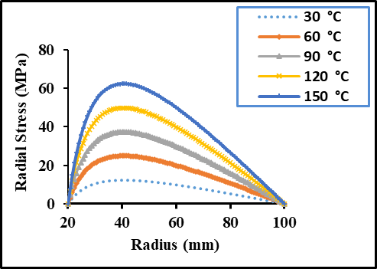
Figure 4. Elastic stress occurring in the radial direction on the CFRP disk
As can be seen in Figure 4, the radial stress increases from the inner region of the CFRP disk to the region of approximately r=42.5 mm. It shows a decrease from this region to the outer part. The tangential stresses formed on the CFRP material disk are given in Figure 4 below.
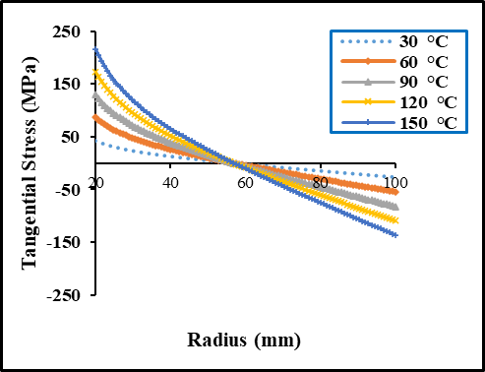
Figure 5. Tangential elastic stress
Radial and tangential stresses are given in Figure 4 and Figure 5 above. It has been determined that the radial stresses are close to zero in the boundary regions of the disk, and the intensity of the stresses in the tangential direction is greater than the stress intensity in the radial direction. It has been seen that the increase in temperature is also clearly reflected in the stresses. For example, for a carbon fiber-reinforced plastic (CFRP) Disk, the tangential stress value is 43.02 MPa on the inner surface and -27.37 MPa on the outer surface for a temperature of 30 °C. At the temperature of 150 ° C, it is 215.11 MPa on the inner surface and -136.88 MPa on the outer surface.
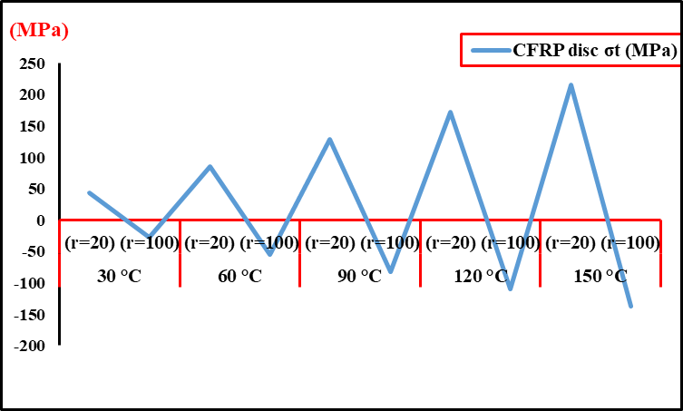
In Figure 6 below, the tangential stresses formed on a disk with CRFP material are given graphically.
Figure 6. Stresses occurring in the tangential direction on the disk with CFRP material

It shows a direct change in tangential stresses with an increase in temperature. ANSYS 2023 program, which is a numerical analysis and Finite Element program, was used for this analysis. It turned out that the results obtained were compatible with each other. In physical evaluation, the importance of verifiable analysis of thermal stresses by a different method has emerged. The accuracy of the results obtained plays a vital role for the machine parts that can be assembled. In this context, the feasibility of a disk model with CFRP (Carbon Fiber Reinforced Polymer) material has been revealed with the study conducted. It was found that the results obtained in the study are compatible with the literature. For example, an elastic stress analysis of the FGM disk was performed in a different study. MATLAB 7.1 program was used during the analysis. Similarly, to this study, it was concluded that stress increases proportionally as the temperature increases (11). Similarly, in different studies, the stresses occurring on disks made of TI and TIB materials were studied by Hencky's stress-strain method. Similarly, to this study, it was determined that radial stresses are maximum in the middle regions of the disk and close to minimum in the innermost and outermost regions (12, 13). In a different study, thermal stresses in the FGM disk were analyzed and it was found that the tangential stress was maximum in the innermost part of the disk and minimum in the outermost region. In this study, it was found that this situation is similar (14).

- CONCLUSION
With this study, the stresses occurring in the disk with CFRP material were determined in different ways. Under the conditions where the parabolic increasing temperature is considered; It was found that there were differences in the stresses calculated for temperatures of 30 °C-60°C-90 °C-120°C and 150 °C depending on the temperature. The radial stress value occurring in a disk with CFRP material is greater than the tangential stress value It has been observed that elastic stresses increase when the temperature increases, tangential stress affects the compression intensity in the inner region of the disk and the tensile intensity in the outer region. At the end of this study, the results obtained showed that the carbon fiber-reinforced plastic (CFRP) disk can be used at high temperatures. It has been seen that the results obtained with the ANSYS 2023 program are very close to the analytically obtained results.
References
1. Cho M, Kim S, Basch R, Fash J, Jang H. Tribological study of gray cast iron with automotive brake linings: The effect of rotor microstructure. Tribology International. 2003;36(7):537-45.
2. Khobragade N, Lamba N. Modeling of thermoelastic hollow cylinder by the application of fractional order theory. Research & Reviews: Journal of Physics. 2019;8(1):46-57.
3. Schajer GS. Practical residual stress measurement methods: John Wiley & Sons; 2013.
4. Hollmann A, Meixner M, Klaus M, Genzel C. Concepts for nondestructive and depth-resolved X-ray residual stress analysis in the near-surface region of nearly single crystalline materials with mosaic structure. Journal of Applied Crystallography. 2021;54(1):22-31.
5. Hosseini E, Holdsworth SR, Flueeler U. A temperature-dependent asymmetric constitutive model for cast irons under cyclic loading conditions. The Journal of Strain Analysis for Engineering Design. 2018;53(2):106-14.
6. Namdari N, Dehghan A. Natural frequencies and mode shapes for vibrations of rectangular and circular membranes: A numerical study. International Research Journal of Advanced Engineering and Science. 2018;3(2):30-4.
7. Sherief HH, Hamza FA. Modeling of variable thermal conductivity in a generalized thermoelastic infinitely long hollow cylinder. Meccanica. 2016;51:551-8.
8. Eraslan AN, Akis T. On the plane strain and plane stress solutions of functionally graded rotating solid shaft and solid disk problems. Acta Mechanica. 2006;181:43-63.
9. VP JS. Theory of elasticity: VEDALAKSHMI; 1970.
10. Wang F, Wang X, Yang R, Gao H, Su Y, Bi G. Research on the carbon fibre-reinforced plastic (CFRP) cutting mechanism using macroscopic and microscopic numerical simulations. Journal of Reinforced Plastics and Composites. 2017;36(8):555-62.
11. Kurşun A, Topçu M, Tetik T. Stress analysis of functionally graded disc under thermal and mechanical loads. Procedia Engineering. 2011;10:2949-54.
12. Kalali AT, Moud SH, Hassani B. Elasto-plastic stress analysis in rotating disks and pressure vessels made of functionally graded materials. Latin American Journal of Solids and Structures. 2016;13:819-34.
13. Çallıoğlu H, Sayer M, Demir E. Elastic–plastic stress analysis of rotating functionally graded discs. Thin-Walled Structures. 2015;94:38-44.
14. Çallioğlu H. Stress analysis in a functionally graded disc under mechanical loads and a steady state temperature distribution. Sadhana. 2011;36:53-64.

